**Binary**  
#include <stdio.h>

#include <stdlib.h>

#include <string.h>

#include <errno.h>

#include <unistd.h>

#include <sys/msg.h>

#define MAX_TEXT 512

struct my_msg_st {

long int my_msg_type;

char some_text[MAX_TEXT];

};

int decimalToBinary(int num) {

long long int bin = 0;

int place = 1;

while (num > 0) {

int remainder = num % 2;

bin += remainder * place;

num /= 2;

place *= 10; }

return bin;

}

int main() {

int running = 1;

struct my_msg_st some_data_bin;

int msgid;

char buffer[MAX_TEXT];

msgid = msgget((key_t)1234, 0666 | IPC_CREAT);

if (msgid == -1) {

fprintf(stderr, "msgget failed with error: %d\n", errno);

exit(EXIT_FAILURE);

}

while (running) {

printf("Enter a decimal number (or 'end' to exit): ")

fgets(buffer, MAX_TEXT, stdin);

buffer[strcspn(buffer, "\n")] = 0;

if (strncmp(buffer, "end", 3) == 0) {

strcpy(some_data_bin.some_text, "end");

some_data_bin.my_msg_type = 2;

} else {

int num = atoi(buffer);

int binary = decimalToBinary(num);

snprintf(some_data_bin.some_text, MAX_TEXT, "%d", binary);

some_data_bin.my_msg_type = 2;

}

if (msgsnd(msgid, (void*)&some_data_bin, MAX_TEXT, 0) == -1) {

fprintf(stderr, "msgsnd failed\n");

exit(EXIT_FAILURE);

} if (strncmp(buffer, "end", 3) == 0) {

running = 0 } }

exit(EXIT_SUCCESS);}

**Sender Terminal:-**

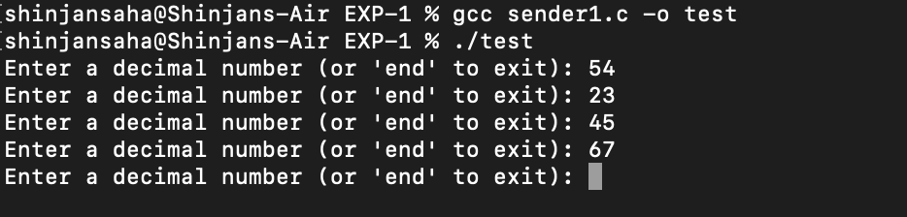

**Receiver Terminal:-**

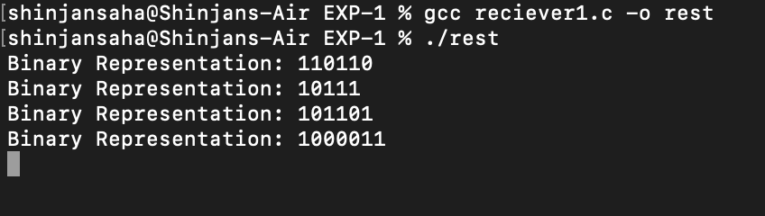

**Octal**

#include <stdio.h>

#include <stdlib.h>

#include <string.h>

#include <errno.h>

#include <unistd.h>

#include <sys/msg.h>

#define MAX_TEXT 512

struct my_msg_st {

long int my_msg_type;

char some_text[MAX_TEXT];

};

int decimalToOctal(int num) {

int octal = 0, place = 1;

while (num > 0) {

int remainder = num % 8;

octal += remainder * place;

num /= 8;

place *= 10; }

return octal;}

int main() {

int running = 1;

struct my_msg_st some_data_oct;

int msgid;

char buffer[MAX_TEXT];

msgid = msgget((key_t)1234, 0666 | IPC_CREAT);

if (msgid == -1) {

fprintf(stderr, "msgget failed with error: %d\n", errno);

exit(EXIT_FAILURE);

}

while (running) {

printf("Enter a decimal number (or 'end' to exit): ");

fgets(buffer, MAX_TEXT, stdin);

buffer[strcspn(buffer, "\n")] = 0;

if (strncmp(buffer, "end", 3) == 0) {

strcpy(some_data_oct.some_text, "end");

some_data_oct.my_msg_type = 2;

} else {

int num = atoi(buffer);

int octal = decimalToOctal(num);

snprintf(some_data_oct.some_text, MAX_TEXT, "%d", octal);

some_data_oct.my_msg_type = 2;

}

if (msgsnd(msgid, (void*)&some_data_oct, MAX_TEXT, 0) == -1) {

fprintf(stderr, "msgsnd failed\n");

exit(EXIT_FAILURE);}

if (strncmp(buffer, "end", 3) == 0) {

running = 0; }}

exit(EXIT_SUCCESS);}

**Sender Terminal:-**

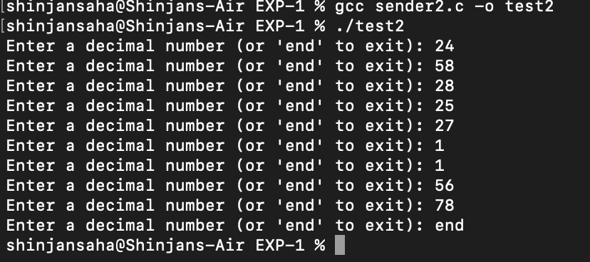

**Receiver Terminal:-**

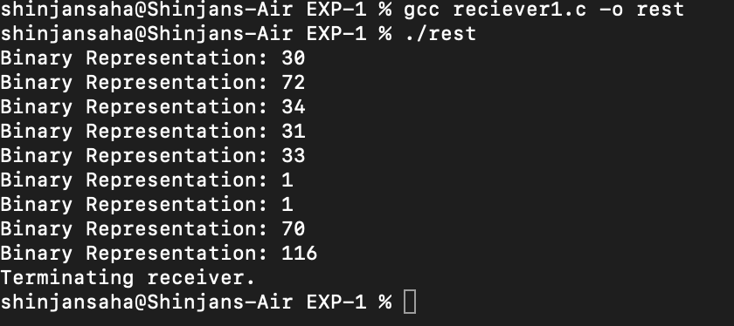

**Hexadecimal**  
#include <stdio.h>

#include <stdlib.h>

#include <string.h>

#include <errno.h>

#include <unistd.h>

#include <sys/msg.h>

#define MAX_TEXT 512

struct my_msg_st {

long int my_msg_type;

char some_text[MAX_TEXT];

};

void decimalToHexadecimal(int num, char *hexStr) {

snprintf(hexStr, MAX_TEXT, "%X", num);

}

int main() {

int running = 1;

struct my_msg_st some_data_hex;

int msgid;

char buffer[MAX_TEXT];

msgid = msgget((key_t)1234, 0666 | IPC_CREAT);

if (msgid == -1) {

fprintf(stderr, "msgget failed with error: %d\n", errno);

exit(EXIT_FAILURE);}

while (running) {

printf("Enter a decimal number (or 'end' to exit): ");

fgets(buffer, MAX_TEXT, stdin);

buffer[strcspn(buffer, "\n")] = 0;

if (strncmp(buffer, "end", 3) == 0) {

strcpy(some_data_hex.some_text, "end");

some_data_hex.my_msg_type = 2;

} else {

int num = atoi(buffer);

decimalToHexadecimal(num, some_data_hex.some_text);

some_data_hex.my_msg_type = 2;

}

if (msgsnd(msgid, (void*)&some_data_hex, MAX_TEXT, 0) == -1) {

fprintf(stderr, "msgsnd failed\n");

exit(EXIT_FAILURE);

}

if (strncmp(buffer, "end", 3) == 0) {

running = 0;}}

exit(EXIT_SUCCESS);}

**Sender Terminal:-**

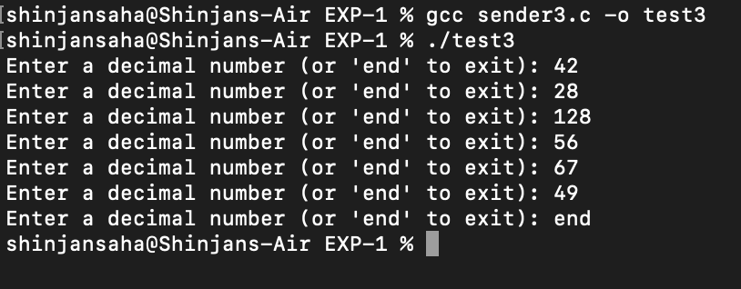

**Receiver Terminal:-**

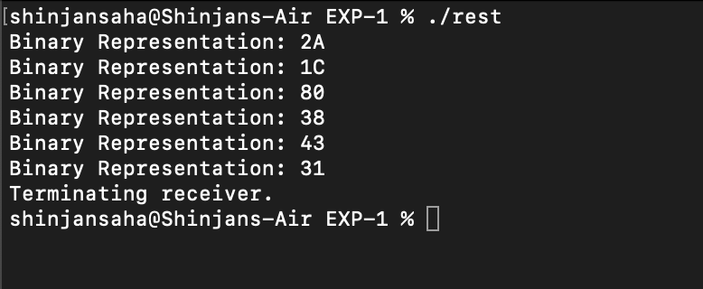

**Receiver**

#include <stdio.h>

#include <stdlib.h>

#include <string.h>

#include <errno.h>

#include <unistd.h>

#include <sys/msg.h>

#define MAX_TEXT 512

struct my_msg_st {

long int my_msg_type;

char some_text[MAX_TEXT];

};

int main() {

int running = 1;

int msgid;

struct my_msg_st some_data;

long int msg_to_receive = 2;

msgid = msgget((key_t)1234, 0666 | IPC_CREAT);

if (msgid == -1) {

fprintf(stderr, "msgget failed with error: %d\n", errno);

exit(EXIT_FAILURE);

}

while (running) {

if (msgrcv(msgid, (void*)&some_data, MAX_TEXT, msg_to_receive, 0) == -1) {

fprintf(stderr, "msgrcv failed with error: %d\n", errno);

exit(EXIT_FAILURE);

}

if (strncmp(some_data.some_text, "end", 3) == 0) {

printf("Terminating receiver.\n");

running = 0;

} else {

printf("Binary Representation: %s\n", some_data.some_text);

}

}

if (msgctl(msgid, IPC_RMID, 0) == -1) {

fprintf(stderr, "msgctl(IPC_RMID) failed\n");

exit(EXIT_FAILURE);

}

exit(EXIT_SUCCESS);

}